Deliverable 5: Final Report

Obesity and Diabetes Trends in the United States (2000–2023)

Abstract
Obesity and diabetes are two closely linked chronic conditions that have increased substantially in the United States over the past two decades. This study examines national trends in obesity and diabetes prevalence from 2000 to 2023 using publicly available summary data. The purpose of this report is to describe long-term patterns, compare growth rates, and explore the relationship between obesity and diabetes at the population level. Visualizations were generated using Python to highlight trends over time. Results indicate a steady rise in both conditions, with obesity increasing at a faster rate than diabetes, suggesting obesity may be a major contributing risk factor.

Introduction
Obesity and diabetes are major public health concerns that contribute to increased morbidity, mortality, and healthcare costs in the United States. Obesity is a well-established risk factor for type 2 diabetes, cardiovascular disease, and other chronic conditions. Over the last several decades, lifestyle changes such as reduced physical activity and increased consumption of calorie-dense foods have accelerated obesity rates. Understanding long-term trends in obesity and diabetes is critical for informing prevention strategies and public health policy. This report analyzes national prevalence trends from 2000 to 2023 to better understand how these conditions have evolved together over time.

Methods
This study analyzed national trends in obesity and diabetes prevalence in the United States from 2000 to 2023 using summarized annual data. The dataset consisted of yearly obesity and diabetes prevalence rates expressed as percentages, representing national-level estimates rather than individual-level observations. The analysis period was selected to capture long-term trends over more than two decades.
Data were organized and analyzed using the Python programming language. The pandas library was used to create and manage a structured data frame containing year, obesity prevalence, and diabetes prevalence variables. Descriptive calculations, including mean prevalence values, were computed directly from this data frame to support comparative analysis.
Data visualization was performed using the matplotlib library. Three figures were generated programmatically: (1) a line chart illustrating obesity and diabetes prevalence trends over time, (2) a bar chart comparing average obesity and diabetes prevalence across the study period, and (3) a line chart showing the yearly difference between obesity and diabetes prevalence rates. All figures were created within the Python environment to ensure reproducibility and consistency.
This analysis relied on publicly available summary data and did not include any personally identifiable information. Because the study used aggregated prevalence estimates, no statistical hypothesis testing was performed. The focus of the analysis was descriptive, aiming to visualize trends and explore the relationship between obesity and diabetes at the population level.

Results

Figure 1. National Obesity and Diabetes Trends (2000–2023)
Description: This line chart displays national obesity and diabetes prevalence over time from 2000 to 2023.
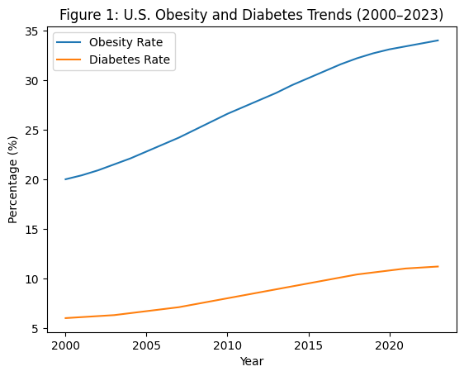
Explanation: Both obesity and diabetes prevalence increased steadily throughout the study period. Obesity rates rose from approximately 20% in 2000 to about 34% by 2023, while diabetes prevalence increased from roughly 6% to just over 11%. The similar upward trajectories indicate that increases in obesity and diabetes occurred concurrently at the population level.

Figure 2. Average Obesity vs. Diabetes Prevalence (2000–2023)
Description: This bar chart compares the average obesity and diabetes prevalence across the entire study period.
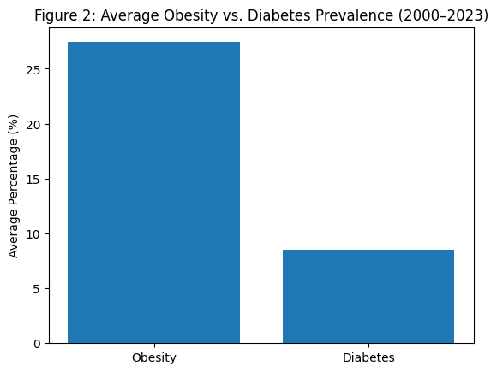
Explanation: Average obesity prevalence was substantially higher than average diabetes prevalence over the 2000–2023 period. This difference highlights the widespread nature of obesity relative to diabetes, while still emphasizing the public health significance of diabetes due to its association with obesity. The comparison provides context for understanding the magnitude of each condition.

Figure 3. Difference Between Obesity and Diabetes Rates (2000–2023)
Description: This line chart shows the yearly difference between obesity and diabetes prevalence rates.
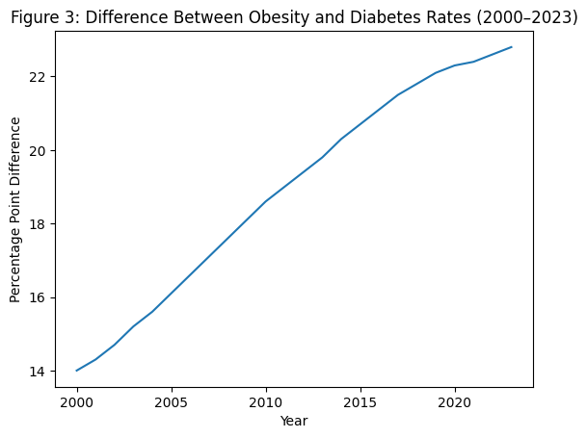
Explanation: The difference between obesity and diabetes prevalence widened consistently over time. This pattern reflects a faster increase in obesity rates compared to diabetes rates across the study period. The growing gap demonstrates that obesity prevalence has risen more rapidly at the population level.

Discussion
The results of this analysis demonstrate a strong temporal association between rising obesity and diabetes prevalence in the United States. Obesity increased at a faster rate than diabetes, suggesting it may act as a leading indicator for future diabetes risk. These findings are consistent with existing literature that identifies excess body weight as a primary risk factor for type 2 diabetes. While this study is limited by the use of aggregated data and lack of demographic stratification, the long-term trends remain clear and concerning. Public health interventions targeting obesity prevention may yield significant downstream benefits in reducing diabetes prevalence.

Conclusion
From 2000 to 2023, both obesity and diabetes prevalence increased substantially in the United States. Obesity showed a more rapid and pronounced rise, reinforcing its role as a major contributor to diabetes risk. These findings highlight the need for sustained public health strategies focused on nutrition, physical activity, and early prevention. Future research should incorporate demographic and regional data to better understand disparities and target interventions more effectively.

References
Centers for Disease Control and Prevention. (2023). National diabetes statistics report. U.S. Department of Health and Human Services. https://www.cdc.gov/diabetes/php/data-research/index.html
Centers for Disease Control and Prevention. (2023). Adult obesity facts. U.S. Department of Health and Human Services. https://www.cdc.gov/obesity/adult-obesity-facts/index.html

